**Class Assignment (NAT)**

1. A. Suppose there are 3 instances of resource tape drives, 3 instances of resource graphics and 2 instances of resource printers. Process 1 holds one unit of resources of both graphics and printers and is waiting for one unit of tape drives. Process 2 holds two units of tape drives and waiting one unit of graphics. Process 3 holds one unit of graphics and one unit of printer. Process 4 holds one unit of tape drive and one unit of grap+hics and waiting for one unit of printer. Draw the resource allocation graph for the above scena++rio+.+ Is the system in a deadlocked state? Expl++++++++++++ain.
2. Draw a wait-for graph from following resource allocation graph. Is +++t+he+r+e any deadlock? Why or +w+hy not explain.+

+++++++++++++++++++++++++++++++++++++++++++++++++++++++++++++++++++++++++++++++++++++++++++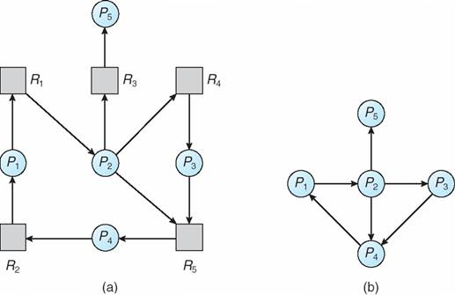 n ++++ 0020 +++ +++++++++++++++++

1. Suppose, in our CSE321 operating system, we have+ a set of resource types, R = {R1, R2, R3, R4, R5} and a set of proc++e+sses, P = {P1, P2, P3, P4, P5}. All the resource types in R have 2, 1, 2, 2 and 2 instances respectively. Processes are organized such that P1 is holding 2 instances of R1, P2 is holding 1 instance of R3, P1 requests 1 instance of R5, P4 is holding 1 instance of R5, P3 is holding 1 instance of R4, P5 requests 2 instances of R3, P4 requests 1 instance of R4, P3 requests 1 instance of R2, P2 requests 1 instance of R1, P5 is holding 1 instance of R5, P2 is holding 1 instance of R2, P1 is holding 1 instance of R4, P3 is holding 2 instances of R3. Draw a resource allocation graph for the above scenario. Is there any possibility of deadlock? Explain why or why not.
2. Draw a wait-for graph from following resource allocation graph. Is there any deadlock? Why or why not explain.

+++

+++-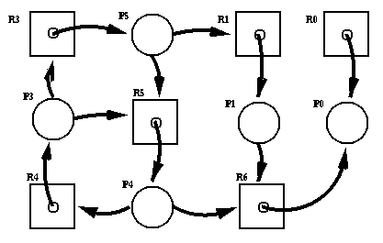

1. Identify the critical section of the following problems:
   1. Suppose, your teacher is checking lab assignment in a class of 30 students. S/he is checking one by one. S/he is also marking individually but s/he can show the marks to all students at the same time. Identify critical section(s) for the case.